LECTURE 1:

Networking: Many standards have to communicate with each other.

Network: system for connecting computers using a single transmission technology.

Internet: set of networks connected by routers that are configured to communicate among a variety of network transmission technologies

Packet switches: forward packets (chunks of data) tranmission rate = bandwidth

**Internetworking:** Universal service over a network of networks

**Communcation Protocols:** reliable transmission

**Ethernet:** Networking standard. 🡪 Made local networking possible

**TCP/IP:** Made internetworking possible

|  |
| --- |
| Preliminaries: Metrics (measurements)  • Speed (distance/time) is measured in electronic units:  – K = 103, M = 106, G = 109, etc. – E.G., network speed of 8 Mbps means 8,000,000 bits per second  • Size in bits, Bytes is measured in binary units  – Commonly used: K = 210, M = 220, G = 230, etc. – In this course, use: Ki = 210, Mi = 220, Gi = 230  – E.G., disk size of 200 GiB means  **200 x 230 Bytes = 214,748,364,800 Bytes 🡪 * 8 = 1,717,986,918,400 bits**  • Bytes and bits (abbreviations)  – Use lower‐case b for bits – Use upper‐case B for Bytes  – Example: 1 Mib = 128 KiB |

4) What is RFC A repository for comments, and the place to find (and post) the adopted standards for networking – in addition to a major resource for students and researchers in networking.

What is the IETF The Internet Engineering Task Force – who produces documentations which lay out standards for the Internet (without official decree).

LECTURE 2

**Protocols define:**

The *format* and *order* of messages sent and received among network entites.

The *actions taken* on message transmission and receipt.

**Network Edge:** -hosts and applications -clients and servers

**End Systems:** Individual pc’s that initiate requests or provide services (pc, cellphone etc)

**Client/Server Model:** client host requires/recevies service from a server that is always on

**Peer2peer model(P2P):** minimal use of dedicated servers (skype/bittorrent)

**Goal:**  Data transfer between end systems

**TCP service:** Transmission Control Protocol 🡪 Internet’s connection oriented service

Handshake/in-order, byte stream data transfer, flow control (sender won’t overwhelm), congestion control(sender slows down rate), (HTTP(web), FTP(file transfer), Telnet(remote login), SMTP(email))

**UDP service:** User Data Protocol 🡪 no handshake/unreliable/no flow/congestion control

Streaming media, Teleconferencing, DNS(Domain Name Service), Internet telephony

**Network Core:** -interconnected routers -network of networks

**Physical Media:** -Communication Links

LECTURE 3a:

**Network Core:**  Mesh of interconnected routers.

**How data is transferred through a network:**

-**circuit switching:** dedicated circuit(phones)

End-to-end resources reserved for call, link bandwidth, circuit-like performance, call-setup required

Network resources are divided into pieces which sit idle if not used by the owning call

Consumers charged/min, 2 ways of dividing link bandwidth (FreqDivisionMultiplexing/TimeDM)

|  |
| --- |
| **How long does it take to send a file of 80 KiB from host A to host B over a circuit‐switched network?**  •The link’s transmission rate = 1.5 Mbps •Each link uses TDM with 24 slots/sec • 500 ms to establish end‐to‐end circuit Figure it out … (watch the K, Ki and s, ms)  • Solution:  – 80 KiB = (80 x 210 Bytes) x (8 bits per Byte) = 640 Kib = 655.36 Kb – Bandwidth of one circuit = (1.5 Mbps)/24 = 62.5 Kbps – Time to send: (655.36 Kb)/(62.5 Kbps) + 0.5s = ~10.5 s + 0.5 s = ~ 11 s |

-**packet-switching:** data sent in chunks

All streams *share* resources, each packet uses full link bandwidth, resources used as needed

**Resource Contention:** aggregate resource demand can exceed available

**Congestion:** Packets queue and wait for link

Source divides outgoing message into packets, recovered by destination

Each packet travels independently 🡪 Includes info for delivery and can take different paths

**Source**: Package construction **Routers:** Transmission **Destination:** Interpretation, receipt.

**Network Core in packet switching: (key functions…theres others)**

*Routing*: Determine source destination

*Forwarding*: Move packets from router’s input to appropriate router output

Other functions: Queing, route discovery, Traffic/congestion control, Retransmit lost packet, Determine data type, etc…

LECTURE 3b:

**Statistical Multiplexing:** Have to share resource (transmissions lines). No fixed pattern, if one pc stops transmitting, other pc gets more use of medium. Shared *on demand*

In TimeDivisonMultiplexing each host gets same slot.

**Circuit Switching:** If two hosts are using medium and one stops there is only 50% utilization.

Allows transmitting at a *constant rate*.

**Packet Switching:** If two hosts are using medium and one stops the other gets more utilization.

Allows more users to use the network!

Not good for time critical information as system can get overloaded.

**Utilization:** Average % of the bandwidth used over a period of time.

LECTURE 4:

LECTURE 5:

M**ultiplexing:** (sometimes contracted to muxing) is a method by which multiple analog or digital signals are combined into one signal over a shared medium. The aim is to share an expensive resource.

**Typical Home Network Components:** Cable/model, router/fireweall/NAT, Ethernet, Wireless access point, devices

**LAN (Loc Ar Ntwrk):** Typically used in companies/Universities

**Wireless:** Standards = 3g/4g/LTE, wireless LAN = in building wide-area wireless = cellphone companies w/ towers

**Physical Media:** Link between sender and reciever

**Two types:** Guided Media 🡪 can touch and see(cables)

Twisted-pair copper wire: cat3:10mpbs,4:100mpbs, Used for high-speed LAN, 99% of connections use this, may pick up noise.

**Connector:** Same on both ends 1,2 connects to 1,2 (pins)…Other pins not used

**Crossover:** Used to connect from 1 pc to another, pins 1,2 transmit to 3,6 recive

**Co-axial Cable:** heavier and more capable than twisted pair, Can’t leave end open Main trunk lines, connecting to acces networks, broadband. Better range thanTwisted pair

**BaseBand** uses a small part of the wave frequency to transmit.

**Broadband** is capable of handling multiple frequencies at once.

Multiple frequency multiplexing: Achieved using different carrier frequencies Frequencies separated to avoid interference, Useful in….

Fiber-Optic Cable: Glass fiber /w light pulses. Not magnetic so low error. Does not use freq dev multiplexing like others. Uses color-div mult using prisms.

Unguided: Signals propagate in every direction

Terrestial Microwave: Up to 45mpbs

LAN

Wide-Area: 3G, 4G, LTE

Satellite: Geostationary/Low-earth Orbit

LAB1:

The **packet capture library** receives a copy of every link-layer frame that is sent from or received by your computer.

LECTURE 6:

Networks are made up of hosts, routers, links, applications, protocols…etc.

Organize through *protocol:* Layering Model

**Layers:** Each layer implements a service -via it’s own internal-layer actions

-relies on service provided by layer above/below

-model used for the course, top-down (below)

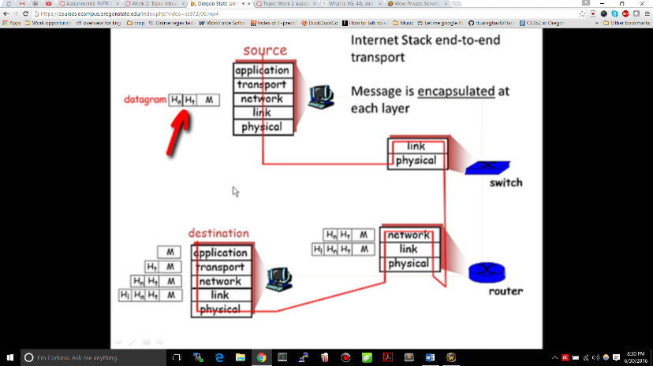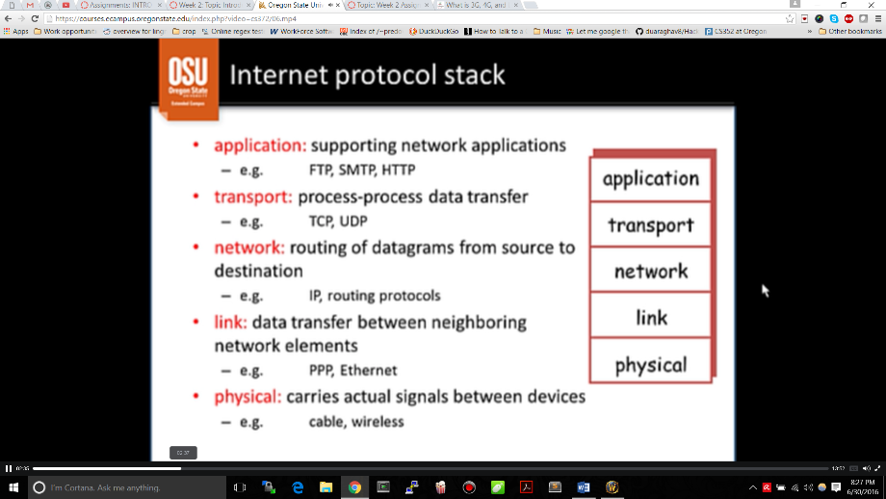

Message is encapsulated by each layer that acts upon it.

Dealing with complex systems:

Explicit structure allows identification and relationship of complex system’s pieces

-Layered reference model for discussion

Modularization eases maintenance and updating of complex system

-Change of implementation of layer’s service is transparent to the others

Primarily implemented in software, because its easier, although slower.

-Each layer must communicate with neighbors, but only through well-defined interfaces

-The software at layer n at destination recieves same protocol message as sender at layer n

-Because of these 2, protocols in stack can be:

-tested independently -modified/replaced independently

ISO/OSI reference model: Under application layer:

🡪presentation layer: Allow application to interpret data meaning

🡪session layer: synchronization, checkpointing, recovery of data

🡪Internet stack missing in these layers

LECTURE7:

Network Security: How computer networks can be attacked intentionally/unintentionally. How to design architecture immune to attacks?

-Originally internet = “A group of mutually trusting users”

-Internet protocol designers playing “catch-up” -Security considerations in all layers

Malware can enter a host from

-**Virus:** Self-replicating infection by receiving/executing object (files)

-**Worm:** Executes itself as it travels around a network

**Spyware malware:** can record keystrokes, websites visited, upload info to collection site

Infected host can be enrolled in BOTNET: Used for spam and DDOS attacks

DDOS: Spam one target by sending a ton of bogus traffic

**Packet Sniffing:** Used on broadcast media (shared ethernet/wireless)

Network interface records packets passing by

**IP spoofing:** Use a fake address to send email to someone else.

LECTURE 8:

The application layer:

Network Applications: e-mail, web, imesage, remote login, VOIP, P2P file sharing, multi-user games

Application architectures:

**Client-Server:** Web browser. Your client sends a request to browser.

Server: -Always on, fixed IP, farms and multi-threading for scaling

Client: -intermittently connected, dynamic IP addrss, no cli/cli comm, only /w serv

**Peer2Peer:** No always-on server, peers intermittently connected, can change IP addresses

Arbitrary end systems communicate directly(no request/response) ex:BitTorrent

**Pros:** Scalable, distributive **Cons:** Difficult to manage, not secure

**VOIP-P2P:** Hybrid, centralized server finds address of remote parties, clients connect directly. (skype, instant messaging)

Process Communication:

**Process:** Program running on a host.

Processes inside a host communicate using *inter-process communication*

Processes in 2 different hosts exchange messages managed by protocols

Addressing Processes:

To receive messages process must have an identifier. IP address of host is not enough to identify the process for proc2proc communication.

**Identifier**: (Socket or Endpoint) Consists of IP address and port number

Server process at specific port number can/can’t serve more than one client directly?

Process recieves/sends message to socket.

**Connection:** Socket pair (consists of client and server IP address and port number) 4 nums

Protocols: HTTP, FTP, SMTP/POP3/IMAP, DNS

Network Core: mostly done using hardware

LECTURE 9: ~~?~??~?~??~?~?~???~?~?~?~?~

LECTURE 10:

Web Page: Base HTML file /w several referenced objects (HTML file, JPEG image, JAVA applet, audio file)

Each object addressed by Uniform Resource Locator (URL)

URL = host name + path name in host directory structure

Client: Formulates request and when it recieves response has to decide how to display it.

Initiates TCP connection to server (port 80) 🡪 Server accepts

HTTP messages are then exchanged, Finally TCP connection is closed by client

HTTP is ‘stateless’: Server saves no information about past client requests

Protocols that maintain state: Complex because if server/client crash, views of state may be inconsistent.

**Nonpersistent HTTP:** At most 1 object sent over TCP cnctn, Download mult objects req mult connections

* 1. Http client init cnct 🡪 1b. Server respons ‘handshake’ 🡪 2. Client sends *request message* 🡪

3. Server forms *response message* and sends 🡪 client recieves response, displays html 🡪

5. PROCESS REPEATED FOR EACH OBJECT (jpeg object, etc..)

**🡪** RTT (round-trip time): Time for a small packet to travel from cli to serv and back.

Ex: One RTT to init TCP cnctn. One RTT for HTTP req/response. File transmit time

Total = ( 2RTT + transmit time ) * (FOR EACH OBJECT)

Operating system overhead for each TCP connection, browsers often open parallel connections

**Persistent HTTP:** Multiple objects sent over single TCP cnctn.

* Good if serving lots of clients
* Server leaves cnctn open after sending response, Cli sends rqst as soon as encounters object.
  + Can be as little as 1 RTT for all objects

**HTTP request**: HOST, User-Agent, Accept (file types), Accept-Language, Accept-Encoding, Accept-Charset

Keep alive (How long to keep connection up)

POST: input uploaded in entity body

GET: input uploaded in URL

**HTTP response:** Status Line (which version of HTTP, includes status code and phrase),

Header Line: Date, Server (type), Last-Modified (requested file), keep-alive etc…..

And then all the data (formatted by browser)

LECTURE 11: **Client-Server State:**

**Cookies:** 1) Header HTTP rspns msg, 2) Header HTTP rqst msg, 3) cookie file on host 4) cookie # serv DB

Before provide authorization, reccomendations, user session state (put burden on the client)

As storage became cheaper, companies began keeping all info on server.

Cookies permit sites to learn about you

**Web Caches:** Satisfy client request w/out involving origin server. Checks proxy server cache first.

Cache acts as *client* and *server*. Cached objects have experation times (if not requested, deleted)

Reduces response time for client request

Reduces traffic, enables poor providers to send better content

Caching No Caching

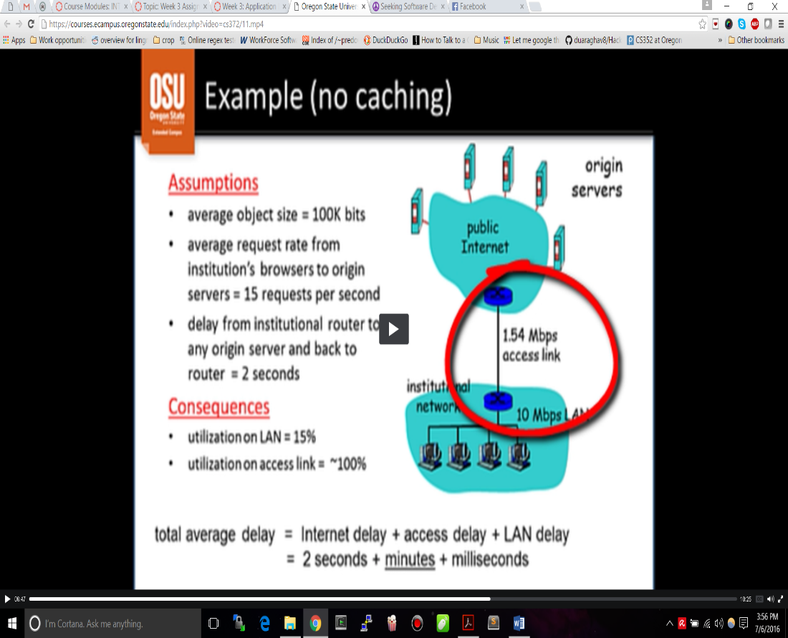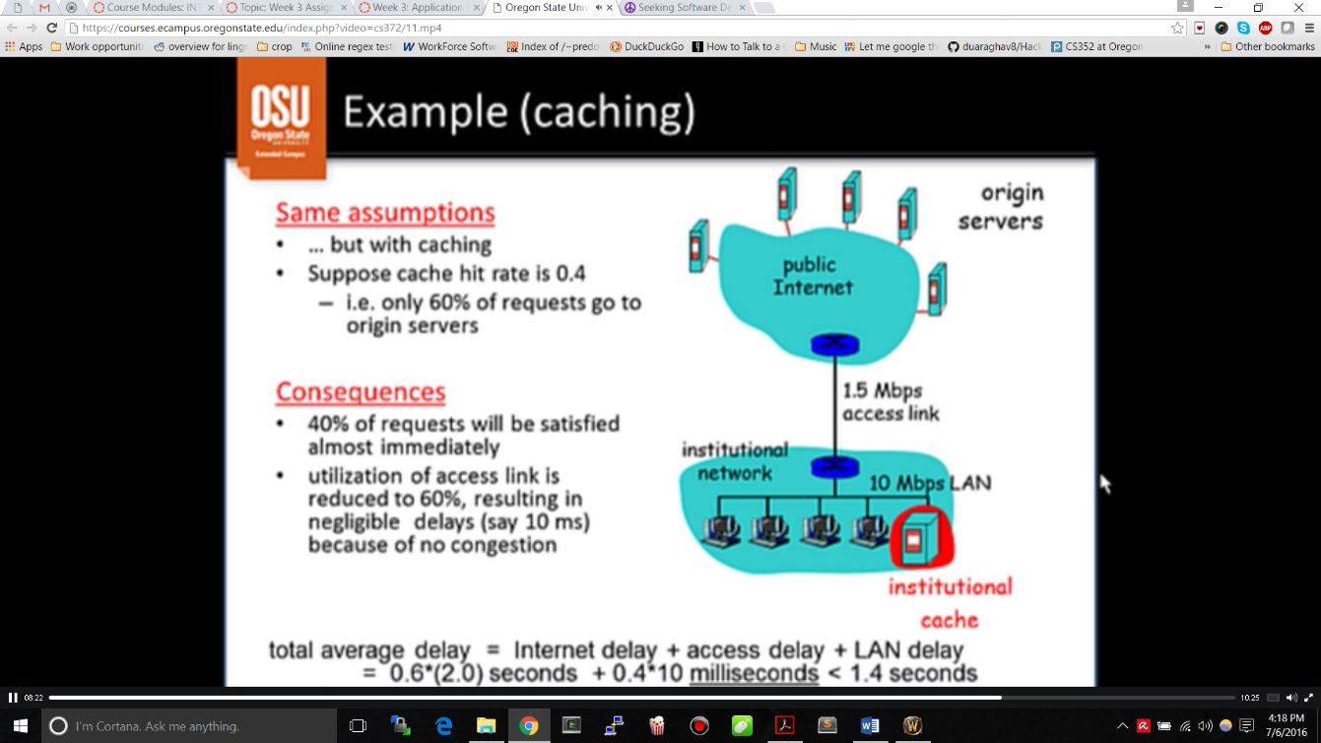

Conditional Get: Don’t send object if cache has up-to-date cached version

Specify date of cached version in http request, server response contains no object in cache is up to date.

LECTURE 12

FTP: File Transfer Protocol 🡪 transfer file to/frm remote host

Client/server model: client initiates, server is remote host

Requires 2 connections: Client contacts server: **Control Connection** (browse directories)

2nd Connection: For file transfer opens and closes when does sending/receiving. 1st stays open

FTP maintains state

EMAIL PROTOCOLS:

3 Components) **User Agent**: Email Client, Compose/Sends mail to server

**Mail Server:** Mailbox contains incoming messages for user, message queue outgoing mail

**SMTP:** Simple Mail Transfer Protocol 🡪 Defines transfer rules and formats between servs

Commands: plain text Response: Status code and phrase, has to be in 7-bit ASCI the composition of commands/msg are handled by user agent. Can communicate directly using SMTP by going through an application protocol. SMTP is *a push protocol. Cannot retrieve messages, need a pull protocol*

**Pull Protocol,** Mail Acess Protocol: **POP (**Post Office Prot), **IMAP**(Internet Mail Access), **HTTP**

**MIME**: Multi-purpose Internet Mail Extension: Allow SMTP to handle more objects that ASCII char

* Like pictures, files

Why do we need mail servers? Need reliability for mail, need connection.

**Mail Message Format:** Header lines entered by user. User Agent formats and sends to provider.

**HTTP:** Used as a mail access protocl for webmail.

**POP3:** Can use download and delete mode., Bob cannot re-read email if he changes client, download and keep copies of messages, POP3 is stateless.

**IMAP:** Keep all msgs in 1 place 🡪 the server,

Keeps user state across sessions,

Allows user to organize messages in folders

Domain Name Services Protocol:

Every host connected to network has unique hardware address **(12 hex digits)**

Not practical for internet addressing.

IANA assign IP network addresss, distributed heirarchically to each sub-user with identifier, same IP

All apps use addresses through TCP/IP protocol

Addresses of domains 🡪 translate to IP addresses for computers. Known as web adress (comcast.net)

* ***Needs to be looked up, not a code. Can’t be converted.***

***No relation between individual fields of address and IP number for****m*

Names are heirarchical starting with rightmsot component (TLD, top-level-domain)

Second from right: DOMAIN NAME WITHIN TLD --Both these parts approved global authority

* Other names then added heirarchically by users
* Left most (www) computer name in domain??
* Orgs apply for name in TLD (nexo, oregonstate, etc) TLD = edu, com, etc…

*Distributed Database:*  implemented in heirarchy of many name servers.

*DNS is an Application Layer protocol*: Runs at host & routers & name servers to resolve names to IP

**DNS SERVICES:**

Hostname to IP address translation

Web server aliasing Why not centralize DNS???

Mail server aliasing

Load distribution

13 root servers worldwide, Resource Records format: (name, value, type, ttl) *ttl 🡪 (seconds in cache)*

**Types:**

A (name is host ; value IP)

CNAME (Name is alias for real name [IB.com is rly ex.IB.com])

NS (name = domain, value = hostname of authoritative name server)

MX (val = mail server)

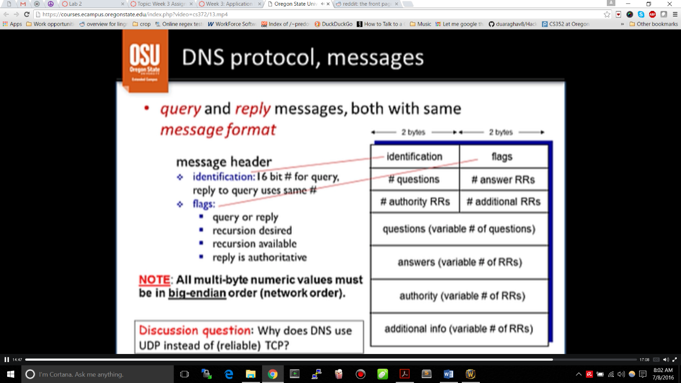Message format is defined.

16bit flags, so 16 flags that can be turned on or off.

# questions: Number of questions to be put into the query field. DNS server has to come back with answer to each one.  
Question and answer are same format.

# of authoritative resource records and additional resource records. These are variable length fields

**All multi-byte numeric values Have to send in Big-Endian order. (Stored as little Endian)**

Intro to Transport Layer:

Transport Protocols: provide logical communication between processes running on different hossts

* Runs on the end ssystem

Sender Protocol

Gets msgs from app socket 🡪 into data blocks 🡪 encapsulates into sgmts 🡪 network layer

Reciever Protocol

Gets from network layer 🡪 re-assembles data blocks to msgs 🡪 msgs to sockets app layer.

Transport layer: Logical communication between processes

Network Layer: Logical comm between hosts (packet addressing/forwarding, route computation)

Large files or multiple users: Multiplexing at sending hosts

Sending host transport protocol: Gathering data from mult sockets, create segments/encapsulating

Receiving host transport protocol: Delivering received segments to correct socket

**Segment: Block of data with source port and destination port**

How demultiplexing works:

Host recieves IP datagrams

**-**Each datagramhas source IP, dest IP addr, source/dest port #

🡪 Each datagram encapsulates one segment layer

Connectionless Demultiplexing:

UDP Socket identified by dest/port #

When host recieves UDP segment directs UDP segment to socket with that port #

Connection-Oriented “”: Identified by all 4 #s (source as well as dest)

All 4 used to direct segment. Server host may support mult TCP sockets.

Web servers have different sockets for each connecting clients

-Non-persistent HTTP have different socket for each request

LECTURE 15

Sockets API: Abstracts the concept of socket so you don’t have to get into gritty details.

OS-controlled interface, Logical port (implemented in software), Created by and assoc/w app on local host

Used by apps to send/receive messages

Two Socket Types: UDP and TCP

UDP: No ‘handshake’, sender attaches IP/port destiniation, reciever extracts sender ip and port.

Data may be lost or received out of order

Application viewpoint:

UDP provides unreliable transfer of groups of bytes (“datagrams”) between client and server

TCP:

Client must contact server

Server creates a new socket for that client. That way server can keep accepting requests.

Sets up a connection.

***Implementations of client and host for sockets can be found in this lecture (in python)!!!!!!!!!***

LECTURE 16

Reliable data transfer

Two Problems:

Cannot gaurantee message will be received and that received message has no errors

The details of the **unreliable channel** dictates complexity of reliable data transfer protocol (rdt)

Reliable: Error detection, Acknowledgements, Sequencing, Timing (flow/congest cntrl), Retransmission, and Fairness

Error Detection in UDP: headers include 16bit checksum and length fields (apart from port number)

**UDP checksum:** Detect errors (flipped/lost bits) in transmitted segment

Sender: start Checksum at 0, compute the 1’s complement of the segment as 16-bit integers

Reciever: Compute Checksum of received segment and compare to checksum field

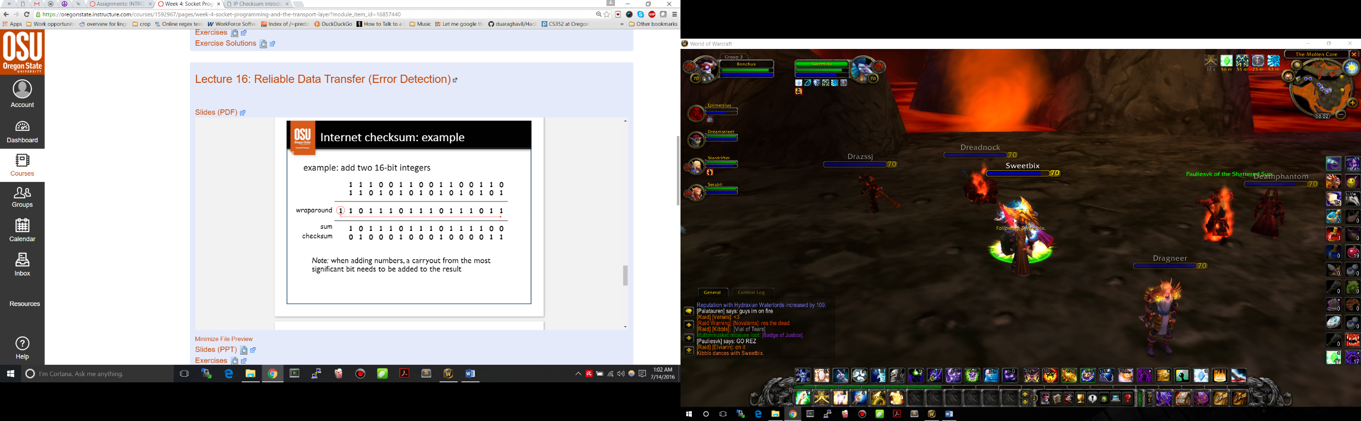Equal:No err detected (may still be errors) ‘

Not Equal: Error, discard packet

LECTURE 17

How can sender know than an error has occurred?

-Bit flipped -Missing packet - Out of sequence

What should reciever do? What should sender do?

**TCP** uses acknowledgement and retransmissions

-**connection oriented**: (handshake initializes sender/reciever before data sent)

-**point-to-point**: one sender, one reciever, fully duplex

-**in-order byte stream**: cumulative byte count, acknowledgement of bytes received

-**pipelined**: TCP congestion and flow control, send & receive buffers

-**flow controlled:** sender will not overwhelm reciever, MSS: maximum segment size

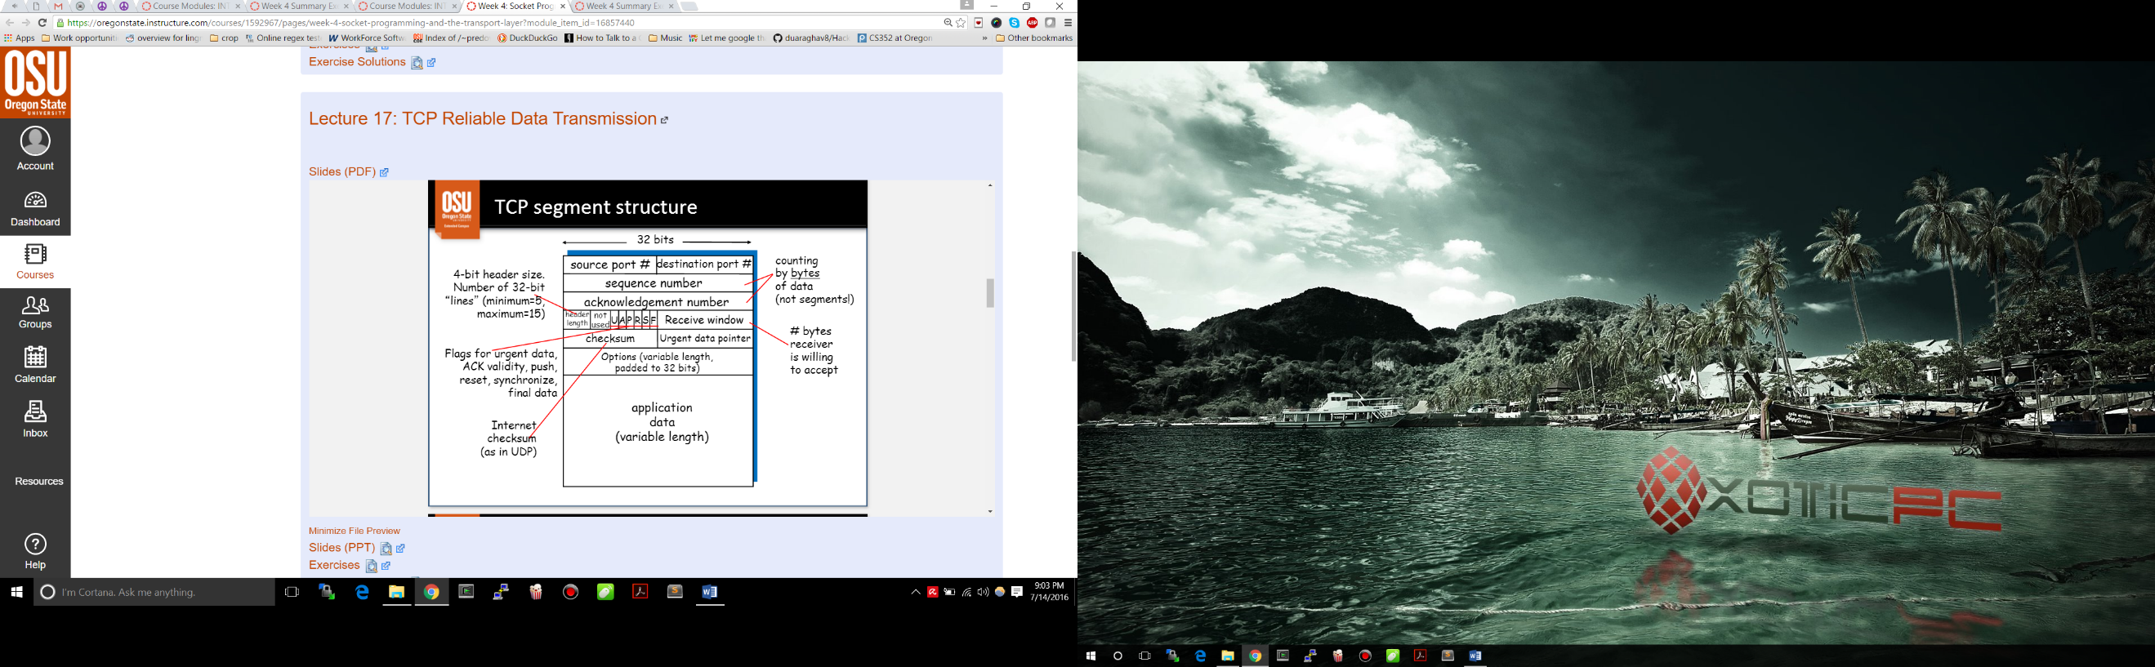

TCP sequence numbers:

Segments are sent as stream of bytes

-protocol keeps track of bytes sent

--Each segment has the byte stream number of the first byte in the squence number field

The sender keeps copy of each segment until acknowledged by reciever

Sender’s segment also has “acknowledgement number”

-TCP is full-duplex

-If nothing to ACK, bogus number put in ACK slot

The reciever ACK’s that all correct segments are received. Header for ACK segment is same as other segments. Reciever calculates data bytes received by subtracting 4x “header length” from total-byte count.

ACK: contains: **number of the next byte expected**

**TCP retransmission:**

Sender sets a countdown timer for each sgmnt sent. If expires before ACK received, re-send.

If a segment error, the ACK will never arrive

Reciever can detect and discard duplicates if ACK is delayed or lost.

LECTURE 18

RELIABLE DATA TRANSFER WITH TCP

TCP’s acknowledgement model is great for reliability but tradeoffs:

Segment overhead, each packet requires at least 1RTT, may increase queueing delay, increases network congestion

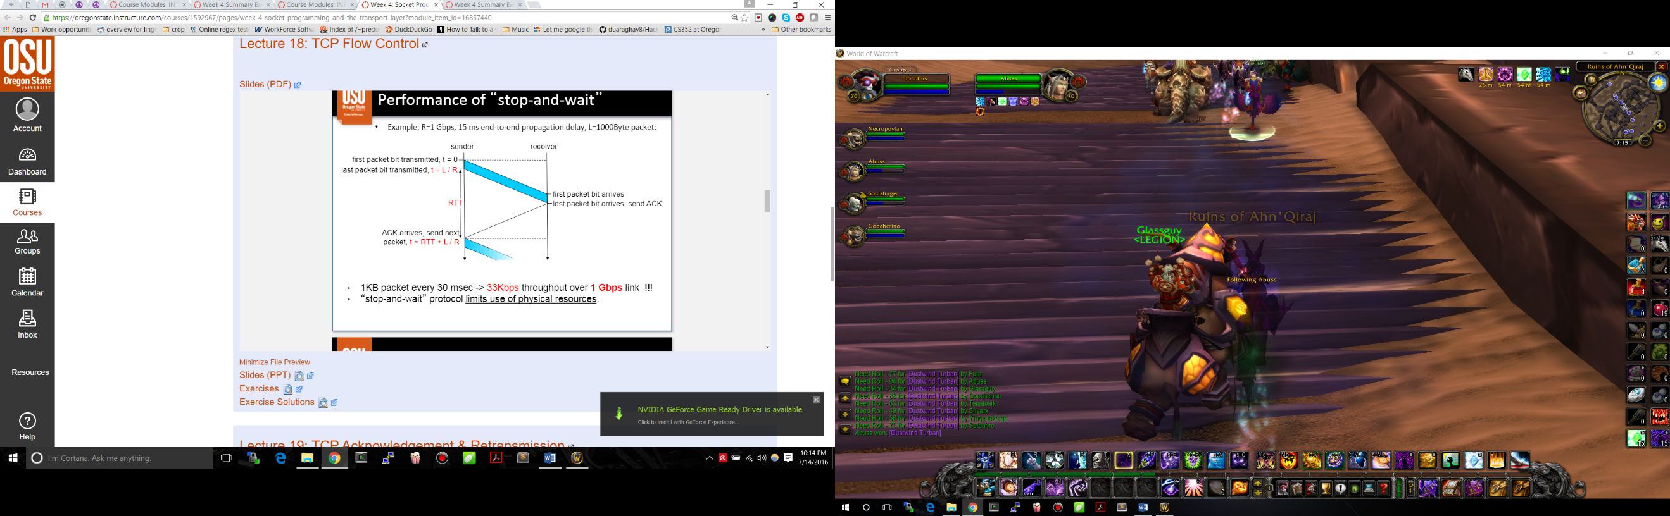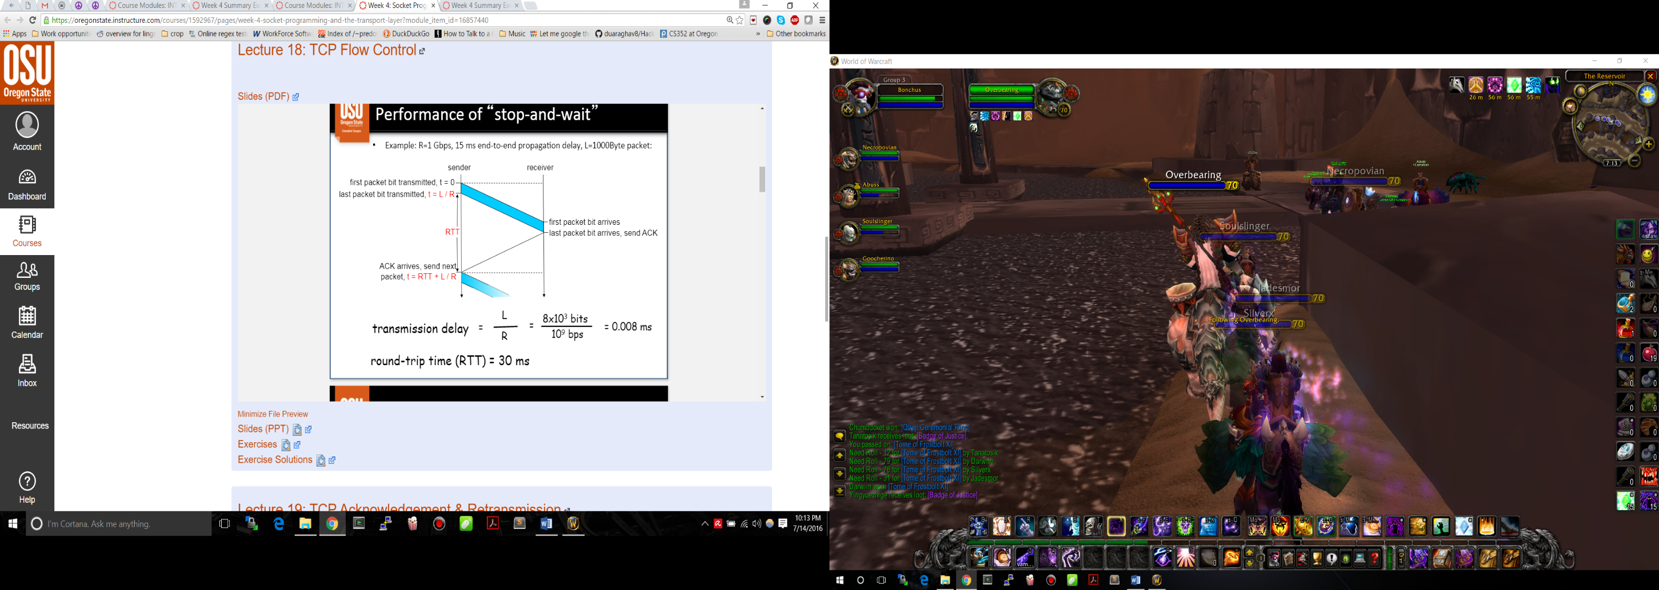 Performance of Stop-and-Wait:

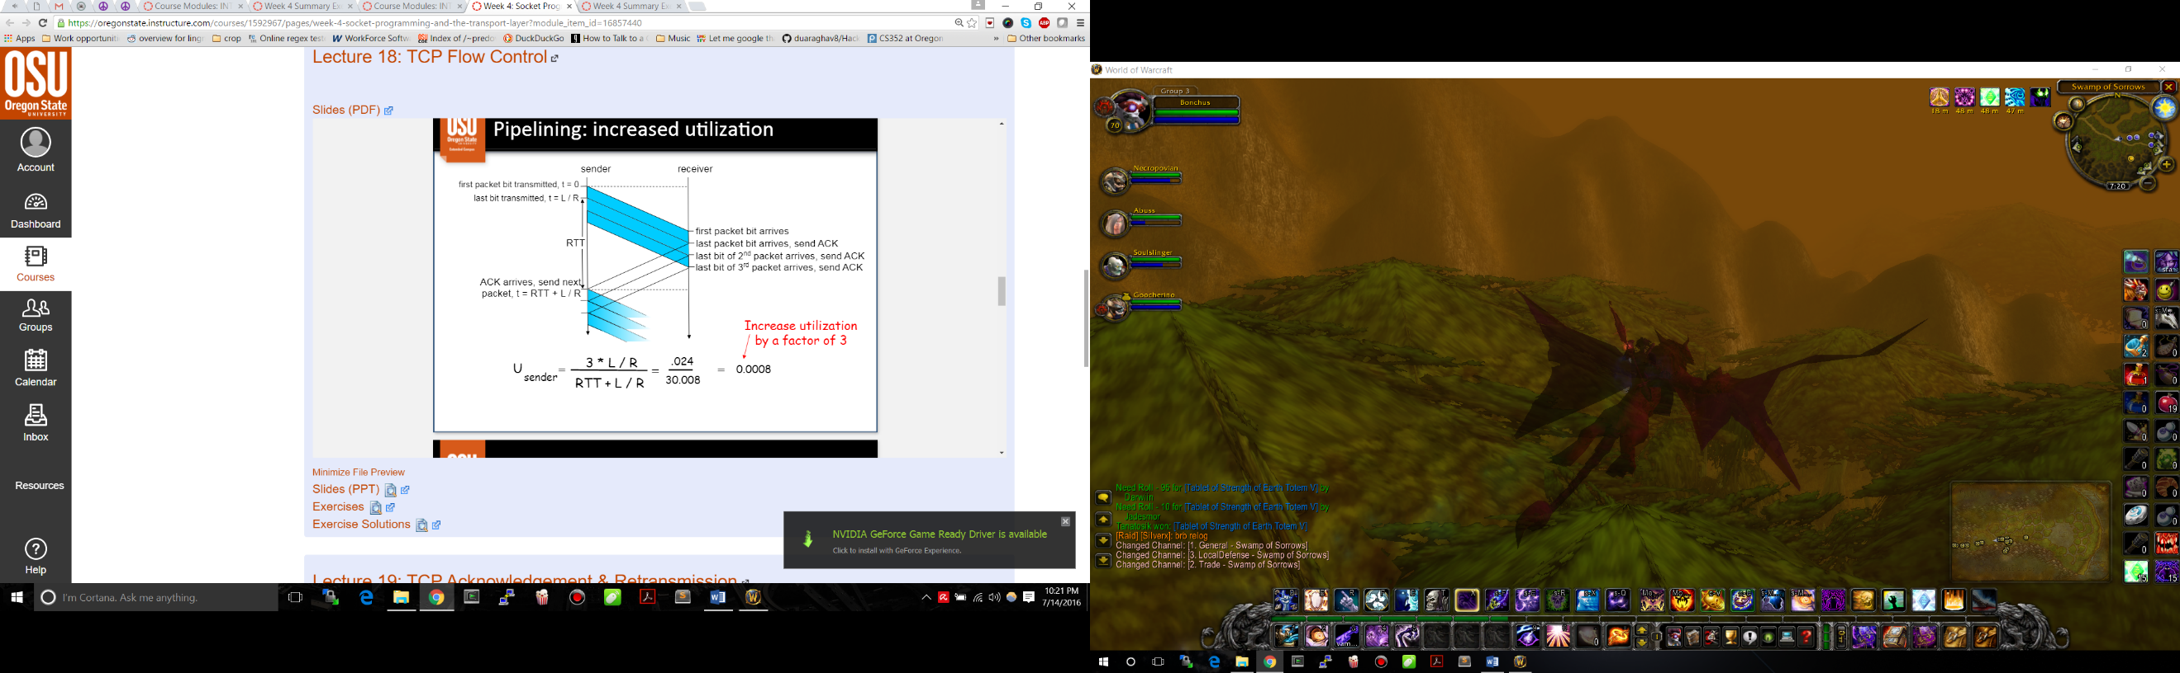With **Piplining:** we can increase utilization by a factor of 3

The Sender transmits multiple packets at a time without waiting for the acknowledgement.

**Problem:** Reciever might not be able to handle that fast. Packets could arrive out of order

TCP flow control: *Sender won’t overlfow by transmitting too fast*

Receive side of TCP connection has a buffer.

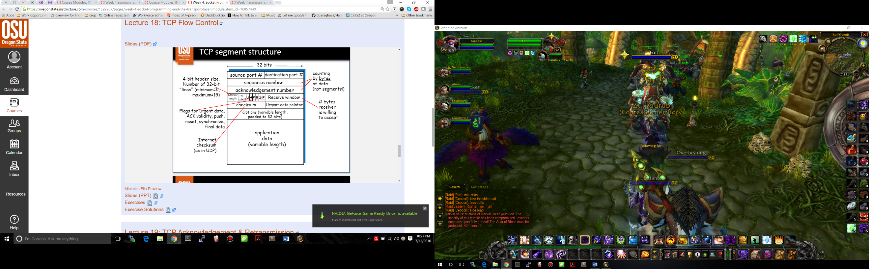***SPEED-MATCHING:*** Matching send rate to drain rate

TCP uses **sliding window** for flow control

1. Sender transmits 1 segment
2. Rec specifies window size in ACK header
   1. Specifies how many bytes in the data stream can be sent
3. Sender limits unACKed data to window

LECTURE 19: RELIABLE DATA TRANSFER WITH TCP (pipline errors: Detection & Handling)

**TCP sender events**: Data comes down from the application layer:

TCP creates segments with sequence numbers (transport layer)

Start countdown timer (if not running for previous segment)

Send segments

**If the countdown expires** resend segment & restart timer

**If ACK** received, check to see it includes the previously unACKed segment,

-update what is known to be ACKed

-restart timer if there are outstanding segments.

How to determine what gets retransimiteed? **Last acknowlegement timer**.

ACK’s are ***cumulative***. The ACK # is always next expected byte number. Implies all previous bytes are acounted for.

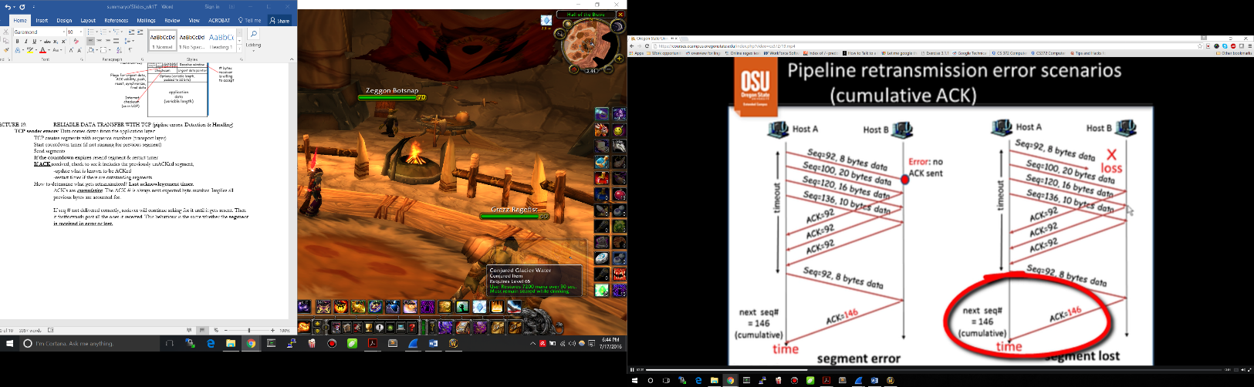If seq # not delivered correctly, reciever will continue acking for it until it gets resent. Then it fastforwards past all the ones it received. This behaviour is the same whether the **segment is received in error or lost.**

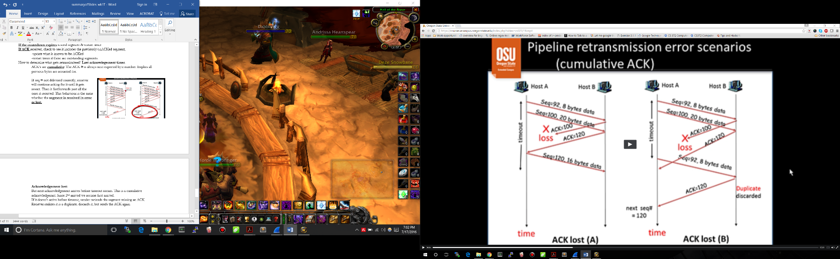**Acknowledgement lost:**

But next acknowledgement arrives before timeout occurs. This is a cumulative acknowledgemnt. Since 2nd arrived we assume first arrived.

If it doesn’t arrive before timeout, sender recends the segment missing an ACK.

Reciever realizes it is a duplicate, discards it, but sends the ACK again.

Sender can have up to “Window size” un-ACK’ed packets in pipeline. Sender maintains timer for every unACK’ed packet, and transmits if timer runs out.

**ACK#: Number of the next byte expected by the reciever**

**Sequence #: number of first byte of sent segment.**

**Fast Retransmit:** Don’t have to wait for timeout on ACK, If we receive 3 same acknowledgements, we retransmit.

---MIDTERM

rekt

--LECTURE 21

As utilization approaches maximum, delay increases

-Excessive traffic is called congestion

-Packets dropped (buffer overflow)

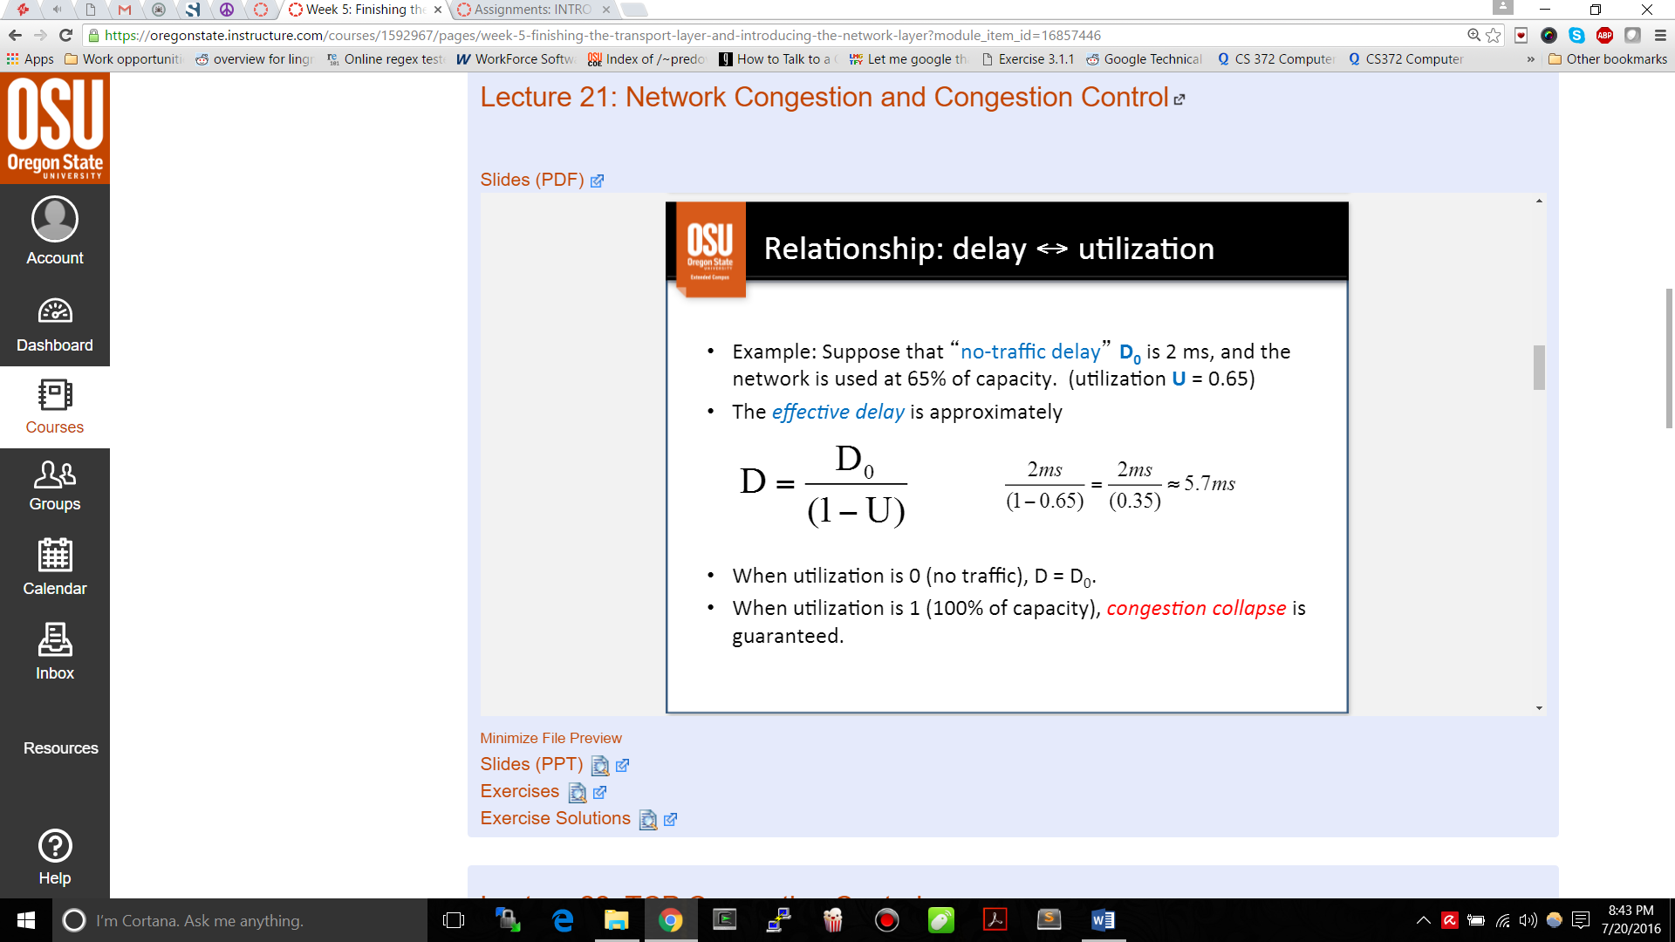 -Slow ACK’s = retransmission

-*congestion collapse*

D: Effective delay U: Network Utilization

Do: Delay when no other traffic

**Congestion Control:**

-optimize util (timeouts, efficient ACK, window mgmt)

-detect/avoid/react to congestion